Sop for chat app

Ver 1.2

Using websocket

Auther by : Sanket sathe

1. Go to chatting app folder and open with vs code

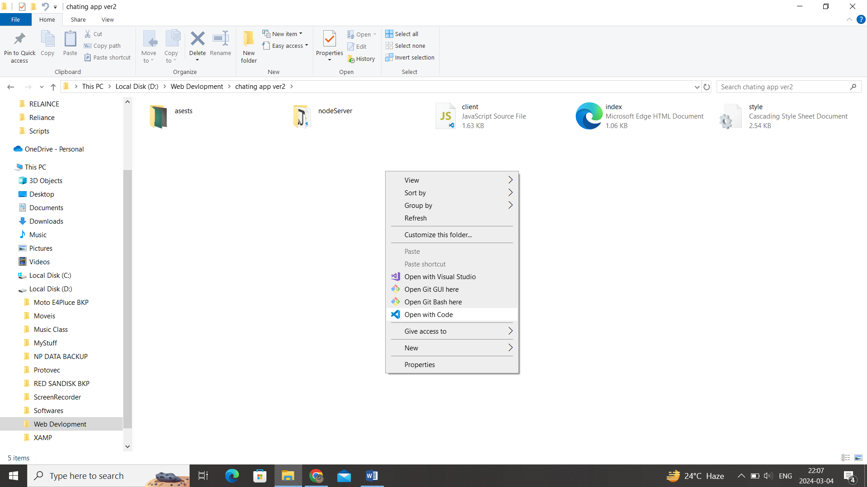

2.open new terminal

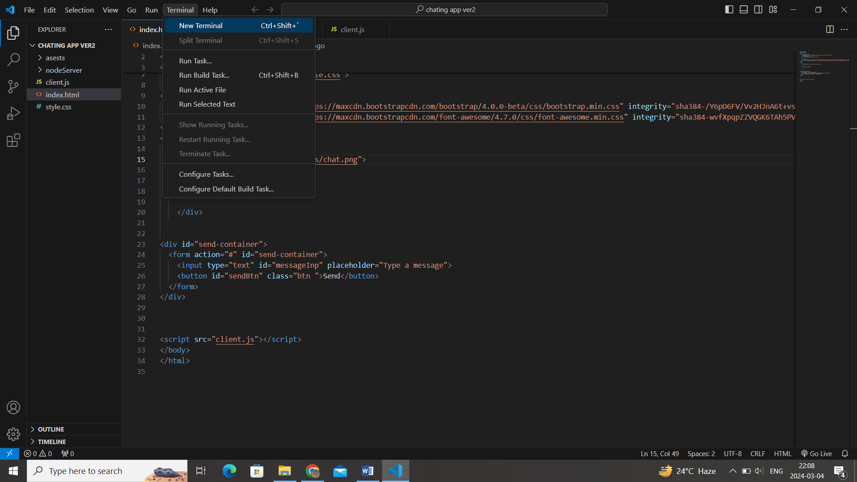

3. Change directory using = cd .\nodeServer\

4 .start node serve using = node .\index.js

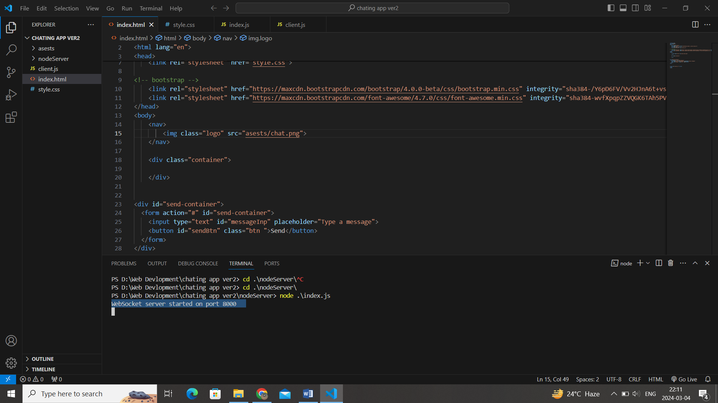

5. open index.html with live server

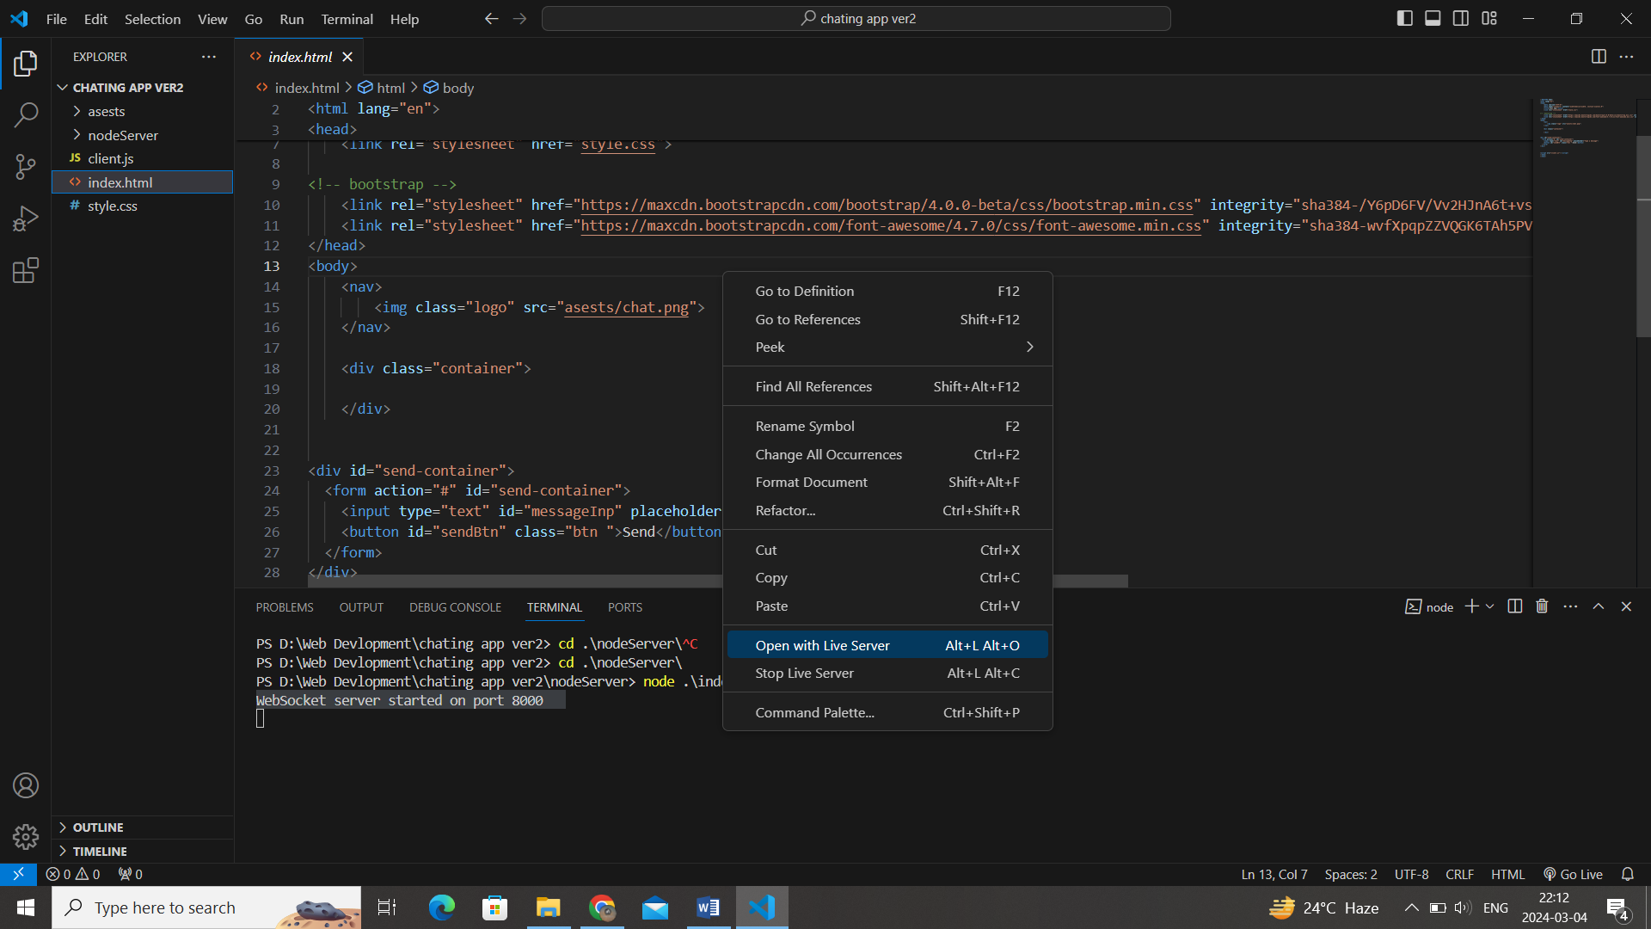

7.open two instance in 2 different tab using this localhost url shown in fig = http://127.0.0.1:5500/index.html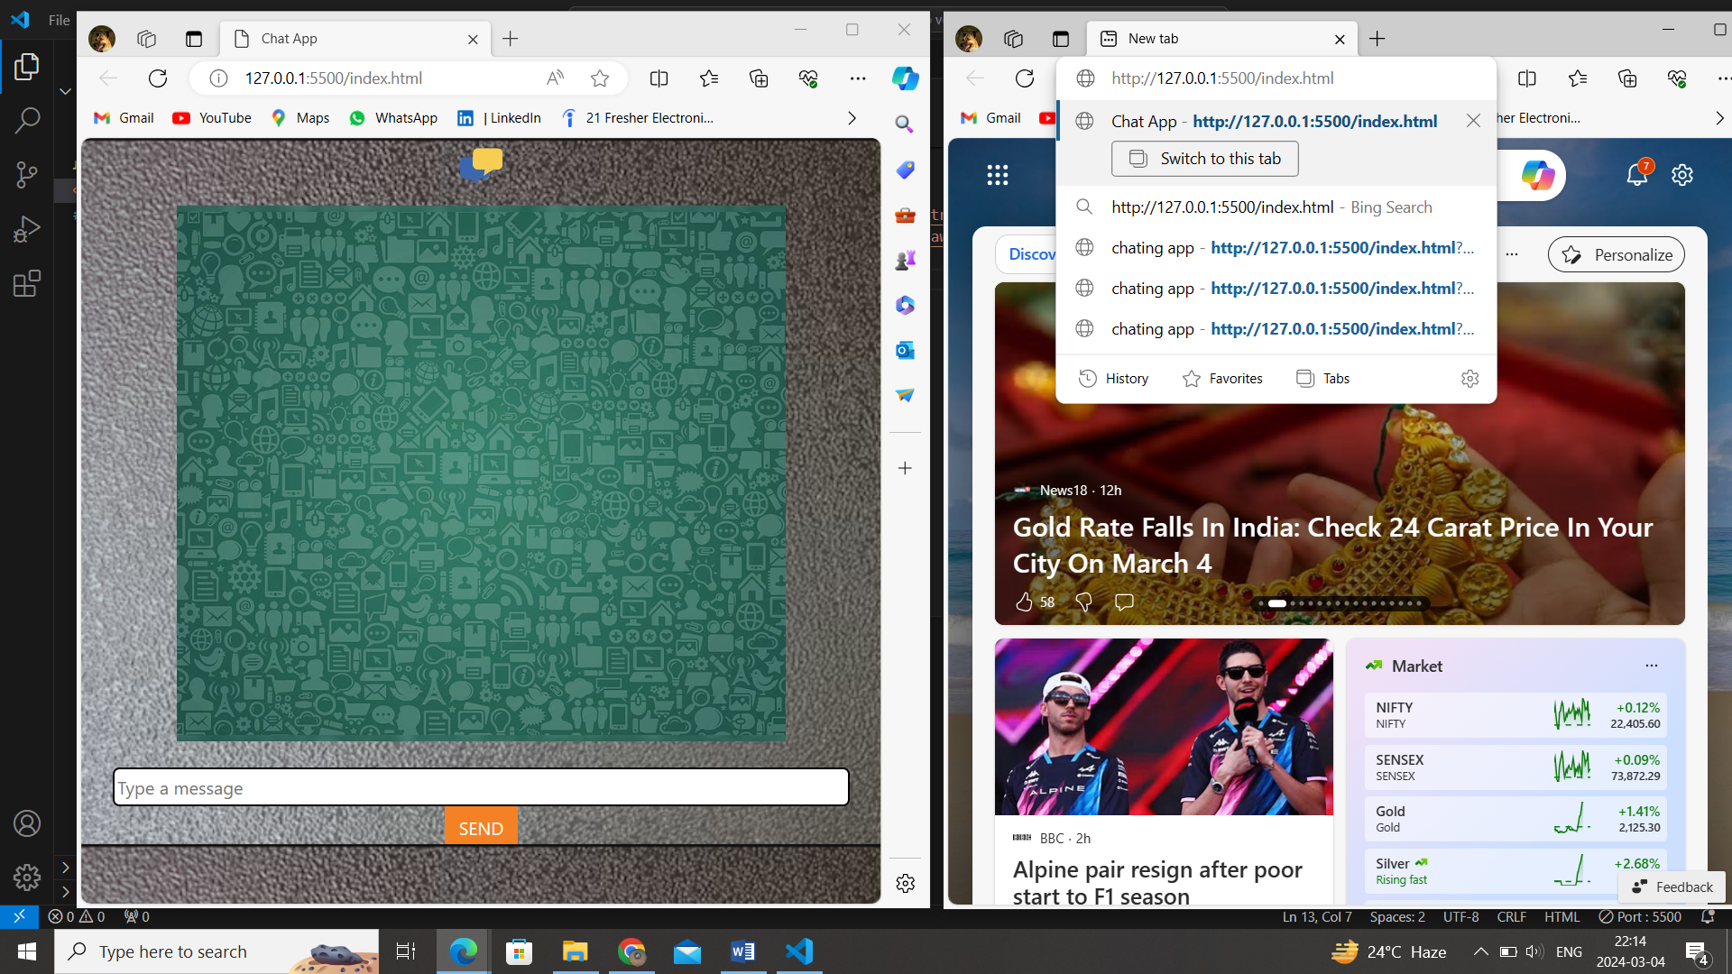

Joing using 2 diffent user and start the chat

